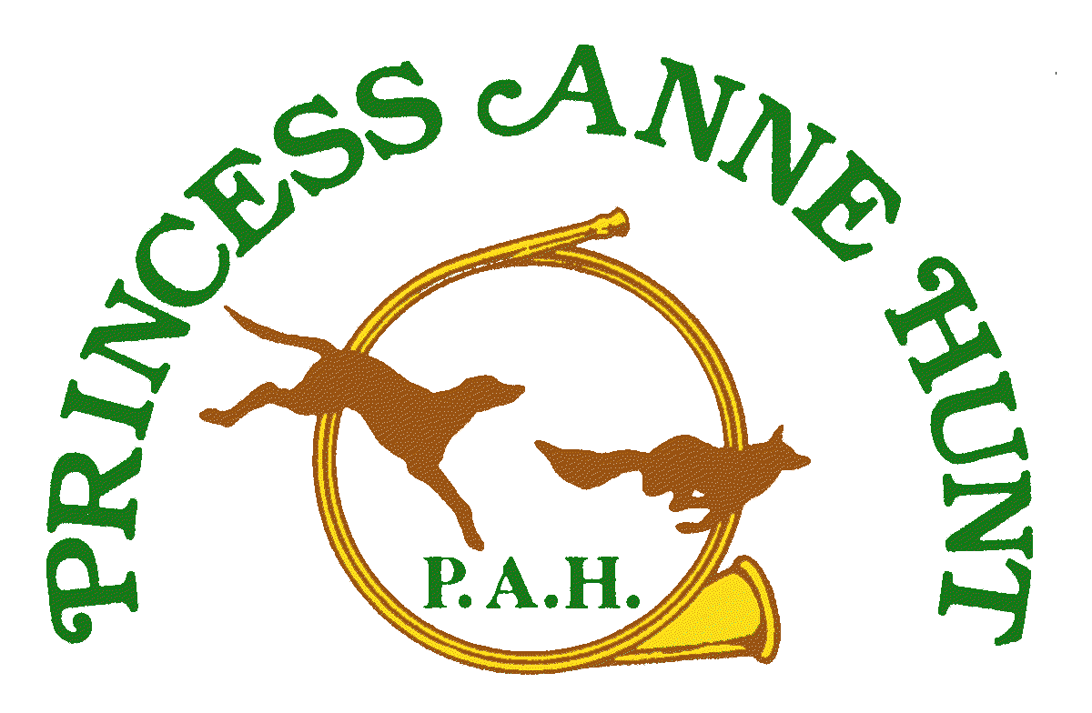
Membership Nomination

Membership Category (check one)

Family ______ Initiation Fee -$900.00($450.00quarterlyly dues) Single ____Initiation Fee- $700.00 ($350.00 quarterly dues) Hunt Supporter _____Initiation Fee - $200.00 ($100.00 quarterly dues)

*Initiation Fee and 1quarter dues fee required at time of Membership Application

Please indicate how you want your dues to be invoiced: Yearly___ Quarterly _____Monthly_____
(does not include Junior, Groom, Professional and Associate Memberships)

Please indicate Initiation/Dues Payment Method: Check#______ Credit Card_____________________

Please indicate any special circumstance with your payment for Membership_______________________________________

Send completed form, with necessary payment and forms to:

Christine Sweet
3199 Quinton Park Trail
Quinton, VA 23141

804 381 1462

Chrissweet3943@aol.com

NOMINEE INFORMATION:

Date:

Candidate’s Name
Sponsor’s Name

Date of Birth Email
Home Address
Home Phone Office Phone

Fax Mobile
Employer Occupation

Work Address

Spouse’s Name

Spouse’s Employer Occupation

Spouse’s Email Office Phone

Fax Mobile

Child’s Name Age Child’s Name Age

Child’s Name Age Child’s Name Age

Horse’s Name Current Coggins (y/n) Date

Age Mare Gelding Current Rabies (y/n) Date

Horse’s Name Current Coggins (y/n) Date

Age Mare Gelding Current Rabies (y/n) Date

What has your horse been used for in the past?

PERSONAL INFORMATION

In which PAH activities have you participated?

Trail Ride Stirrup Cups Hill Topping Hunting Hunt Ball
Please list any previous hunting experience or other hunt affiliation

Involvement in equestrian activities outside of hunting

What PAH activities are of particular interest to you?

As a volunteer organization, our committees are a very important aspect of the club. On which PAH Committees are you willing to serve? (Membership, Fund Raising, Finance, Trail Clearing, Social)

FOR JUNIOR NOMINEES UNDER 18 YEARS OF AGE

Parent(s)/Guardian(s) Name

Address: Email

Phone (h) (w) (mobile)

Employer Occupation

Address

SPONSOR INFORMATION
Please complete this section and attach a letter of recommendation.

Proposer Seconder

Signature Signature

Please Print Name Please Print Name

Please list those Board Members familiar with the nominee

The undersigned candidate confirms that the information contained herein is true, and correct and consents to his/her being nominated for membership.

Candidate Signature

BOARD COMMENTS: Date Submitted Approved

Levels of Membership
FAMILY MEMBERSHIP (F) – Family memberships shall consist of husband and/or wife, and all dependent children when there is more than one rider in the family who intends to follow hounds on horseback. A dependent shall be defined as any relative below the age of (26) or full time student, residing in the household of a member, and relying on the member for at least one-half (1/2) of his or her support. The husband and/or wife shall each be entitled to one (1) vote. Cub hunting will be permitted at the invitation of the Master of Foxhounds.

Initiation Fee - $900 Quarterly Dues - $450.00

SINGLE MEMBERSHIP (S) – Single members shall consist of those over the age of twenty-five (25) who are the sole riding participants in a family. A single member's spouse and dependents (as defined above) shall have all the privileges of the Corporation, except the right to vote or follow hounds on horseback. Only the riding member shall enjoy that privilege. Cub hunting will be permitted at the invitation of the Master of Foxhounds.

Initiation Fee - $700 Quarterly Dues - $350.00

PROFESSIONAL MEMBERSHIP (P) – A Professional membership shall be an annual membership (i.e. subject to annual renewal by the board of directors), consisting of an individual whose PRIMARY source of income is training and/or boarding horses, or teaching equitation and who intends to follow hounds on horseback. (Any professionals that would be IN question would be at the discretion of the board) With the permission of the Master of Foxhounds, a Professional Member may bring his/her students as guests. Student guests may, upon payment of full cap, hunt two (2) times per season [note: if a student is considering joining and desires more than two hunts to try out the sport of mounted foxhunting, then additional Caps may be permitted upon approval of the Master of Foxhounds]. Professional Members shall have all the privileges of the Corporation except earning colors, staff positions or the right to vote. Cub hunting will be permitted at the invitation of the Master of Foxhounds.

Initiation Fee - none Annual Dues - $500

GROOM MEMBERSHIP (G) – A Groom membership shall be an annual membership (i.e. subject to annual renewal by the board of directors), consisting of an individual who is employed by a Family Member or Single Member in good standing for the care, training, and/or exercising of the Member’s horses; and who intends to follow hounds on horseback. Grooms should generally ride toward the rear of the field. The Groom may ride the member's horse near or at the front of the field by Invitation of the Field Master. A Groom Member shall have all the privileges of the Corporation except earning colors, staff positions or the right to vote.
Cub hunting will be permitted at the invitation of the Master of Foxhounds.

Initiation Fee - none Annual Dues - $250.00

HUNT SUPPORTER (HS) – Hunt Supporters shall consist of members who wish to demonstrate their interest in and support of fox hunting through participation in such portions of the hunt as the Stirrup Cup, Hill-topping, Breakfasts, and other social events. Hunt Supporters may, upon payment of full cap, hunt two (2) times per season. Hunt Supporters shall be entitled to all other privileges of the Corporation except the right to vote.

Initiation Fee - $200 Quarterly Dues - $100.00

JUNIOR MEMBERSHIP (J) – Junior members shall consist of those twenty-five (25) years of age and under who are not included in a Family Membership. They shall have all the privileges of the Corporation except the right to vote. Cub hunting will be permitted at the invitation of the Master of Foxhounds.

Initiation Fee – none Annual Dues - $250.00

ASSOCIATE MEMBERSHIP (A) – An Associate membership shall be an annual membership (i.e. subject to annual renewal by the board of directors), consisting of an individual who does not reside in the corporation’s territory; who is a member of an MFHA-recognized hunt, and has been for a period of at least 3 years; and who intends to follow hounds on horseback. An Associate Member shall have all the privileges of the Corporation except earning colors, staff positions or the right to vote. Cub hunting will be permitted at the invitation of the Master of Foxhounds.

Initiation Fee - none Annual Dues - $500.00

AGREEMENT FOR RELEASE AND WAIVER OF LIABILITY
I request permission to participate in cross-country riding and foxhunting with PRINCESS ANNE HUNT.
I fully understand that cross-country horseback riding and foxhunting (which includes riding over fences, other obstacles, and steep rough terrain) are very dangerous activities. I wish to participate in these activities knowing they are dangerous. I accept and assume all the risks of injury (including death) to me or my property.
In exchange for being permitted to participate in these activities, for myself, my heirs, guardians, and legal representatives, I release and agree not to make or bring any claim of any kind against PRINCESS ANNE HUNT, or its MASTERS, EMPLOYEES, GUESTS OR ANY LAND OWNERS, LANDHOLDERS OR OTHER PERSONS MAKING PROPERTY AVAILABLE FOR PRINCESS ANNE HUNT, for any injury (including death), to me or any damage to my property whether from anyone’s negligence or not, or any other cause, arising out of my participation in these dangerous horseback riding, fox hunting or related activities; and I also agree if anyone makes any claims because of any injury to me (including death), or for any damage to my property, I will keep all those released by this agreement free of any damages or costs because of those claims.
DATED_____________SIGNATURE_______________________________
PRINT NAME__________________________________________________
Address________________________________________________________
Phone Number__________________________Guest of________________________________________
In case of Emergency Notify____________________________Phone/CellNumber_______________________
Preferred Hospital _______________________Doctor’sName__________________Phone______________
Current Medical Condition__________Medications_______________Allergies_____________________

RIDERS PLEASE COMPLETE THE FOLLOWING
HORSE COGGINS INFO
Lab Access. #_______________ Horse Name ________________________________
Test Date_________________ State______
HORSE INFORMATION: Veterinarian_______________________________Phone___________________
I authorize emergency medical treatment for my horse, or myself, and understand that medical personnel other than those listed above may administer this treatment.
Signature__________________________PrintName__________________Date_____
HUNTING LICENSE VA Hunting License #_________________________Date_______________
CAP FEE PAYMENT METHOD: circle one- CASH ______CHECK #________ INVO

